**Intelligent Drowsiness Monitor For Safe Driving**

**Using Deep Learning**

**Developed by: Abhinav Kumar Pathak, Rishi Pradeep Sharma, Abhilash Anand and Himanshu shekhar**

**Smart Bridge-Remote Summer Internship Program**

1. **INTRODUCTION**

A car accident is the major cause of death in which around 1.3 million people die every year. The majority of these accidents  
are caused because of distraction or the drowsiness of the driver. Construction of high-speed highway roads had diminished  
the margin of error for the driver. The countless number of people drive for long-distance every day and night on the  
highway. Lack of sleep may lead to an accident. According to the National Highway Traffic Safety Administration and the Centre’s for Disease Control and Prevention they say that it is 7 times dangerous driving tired to driving drunk. Drivers must keep a close eye on the road, so they  
can react to sudden events immediately

* 1. **OVERVIEW**

This document is a review report on the research conducted and the project made in the field of computer engineering to develop a system for driver drowsiness detection to prevent accidents from happening because of driver fatigue and sleepiness. The report proposed the results and solutions on the limited implementation of the various techniques that are introduced in the project. Whereas the implementation of the project give the real world idea of how the system works and what changes can be done in order to improve the utility of the overall system.

* 1. **PUPOSE**

Neglecting our duties towards safer travel has enabled hundreds of thousands of tragedies to get associated with this wonderful invention every year. It may seem like a trivial thing to most folks but following rules and regulations on the road is of utmost importance. While on road, an automobile wields the most power and in irresponsible hands, it can be destructive and sometimes, that carelessness can harm lives even of the people on the road. One kind of carelessness is not admitting when we are too tired to drive. In order to monitor and prevent a destructive outcome from such negligence, many researchers have written research papers on driver drowsiness detection systems. But at times, some of the points and observations made by the system are not accurate enough. Hence, to provide data and another perspective on the problem at hand, in order to improve their implementations and to further optimize the solution, this project has been done.

1. **LITERATURE SURVEY**

This survey is done to comprehend the need and prerequisite of the general population, and to do as such, we went through different sites and applications and looked for the fundamental data. Based on these data, we made an audit that helped us get new thoughts and make different arrangements for our task. We reached the decision that there is a need of such application and felt that there is a decent extent of progress in this field too.

* 1. **EXISTING PROBLEM**

Drowsiness is a safety problem that has not yet been deeply tackled by any country in the world mainly because of its nature. In general, is very difficult to measure or observe unlike alcohol and drugs, which have clear key indicators and tests that are available easily. Probably, the best solution to this problem is to take breaks between long driving hours. But, as we all know we can’t control someone minds or consult them to rest out of nowhere. It is not possible without the former as driving for long hours is very lucrative.

* 1. **Proposed Solution**

To overcome the above problem of drowsiness we are building the deep learning intelligence model. In this model we have used deep learning python libraries such as OpevCV tensorflow etc. The model is built to detect the drowsiness of the person while driving. The model consist of image recognition and video streaming. It consist of an alarm which rings when the driver drouse, yawn, or blink multiple times.

1. **FLOW CHART**
2. **Use case diagram**

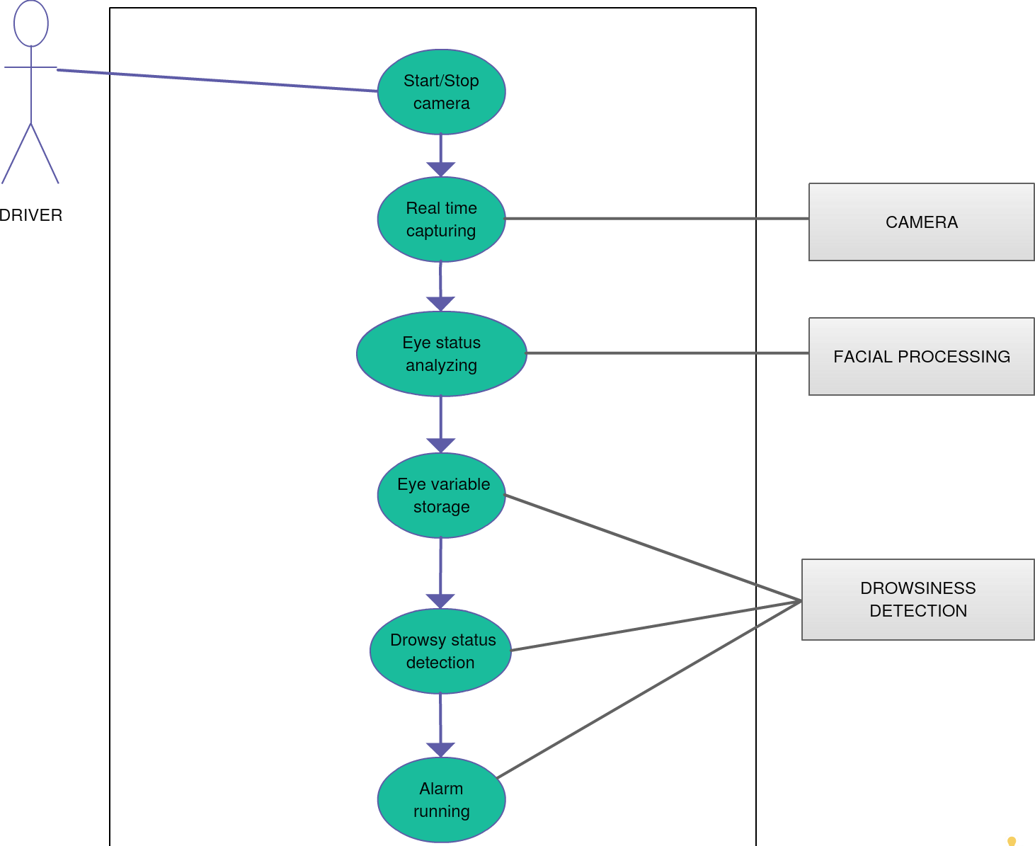

**Figure 1**

1. **Activity Diagram**

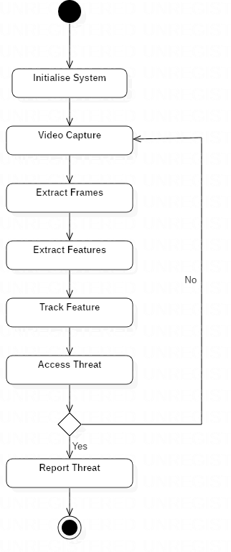

Figure 2

**c. Block Diagram**

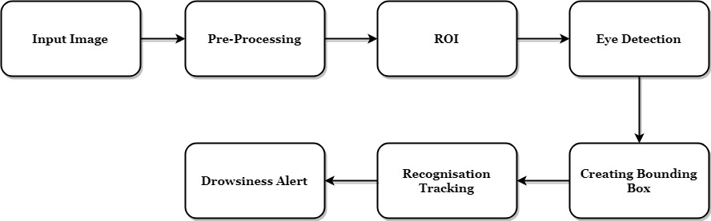

1. **Software Designing**
2. PYTHON - Python is an interpreted, high-level, general-purpose programming language. Python's design philosophy emphasizes code readability with its notable use of significant whitespace. Its language constructs and object-oriented approach aim to help programmers write clear, logical code for small and large-scale projects. Python is dynamically typed AND supports multiple programming paradigms, including procedural, object-oriented, and functional programming.
3. Spyder IDE: Spyder is an open source cross-platform integrated development environment for scientific programming in the Python language.
4. IMAGE PROCESSING - In computer science, digital image processing is the use of computer algorithms to perform image processing on digital images.
5. MACHINE LEARNING - Machine learning is the scientific study of algorithms and statistical models that computer systems use in order to perform a specific task effectively without using explicit instructions, relying on patterns and inference instead. It is seen as a subset of artificial intelligence. Machine learning algorithms build a mathematical model based on sample data, known as "training data", in order to make predictions or decisions without being explicitly told.
6. DEEP LEARNING - Deep learning is part of a broader family of machine learning methods based on artificial neural networks with representation learning. Learning can be supervised, semi-supervised or unsupervised.
7. OPENCV- OpenCV is a library of programming functions mainly aimed at real-time computer vision. Originally developed by Intel, it was later supported by Willow Garage then Itseez. The library is cross-platform and free for use under the open-source BSD license.
8. DLIB - Dlib is a general purpose cross-platform software library written in the programming language C++. Its design is heavily influenced by ideas from design by contract and component-based software engineering. Thus it is, first and foremost, a set of independent software components.
9. **RESULT**

Implementation of drowsiness detection with Python and OpenCV was done which includes the following steps: Successful runtime capturing of video with camera. Captured video was divided into frames and each frame were analyzed. Successful detection of face followed by detection of eye. If closure of eye for successive frames were detected, then it is classified as drowsy condition else it is regarded as normal blink and the loop of capturing image and analyzing the state of driver is carried out again and again.

1. **PROJECT SNAPSHOTS**

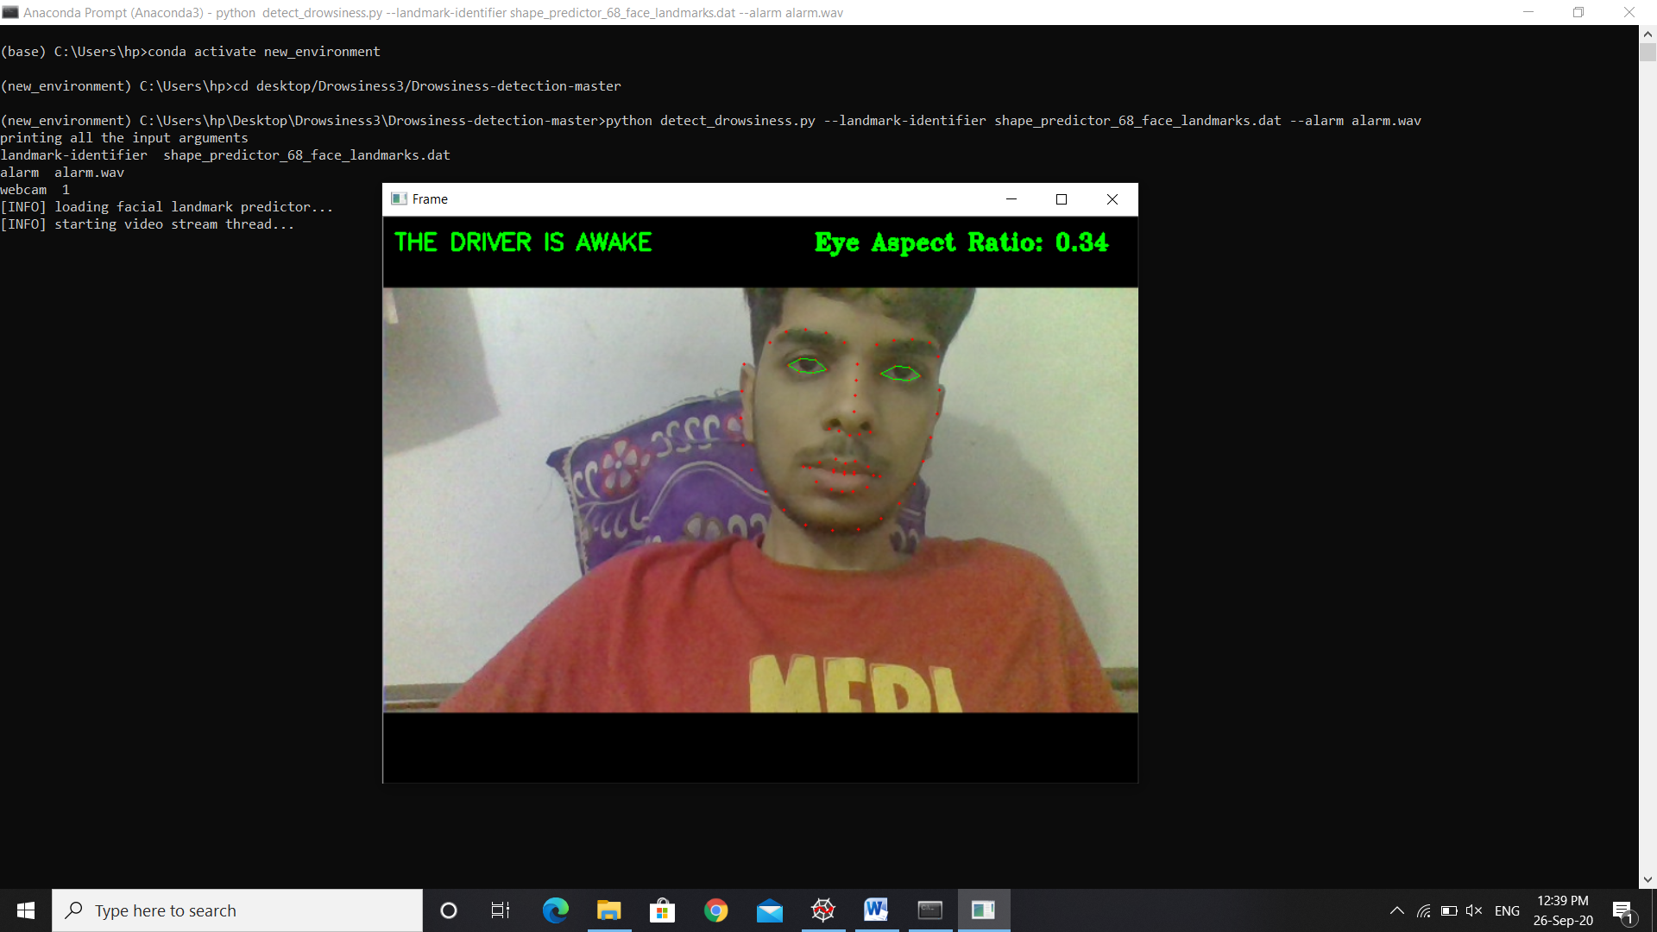

FIGURE 1- NON DROWSY PERSON

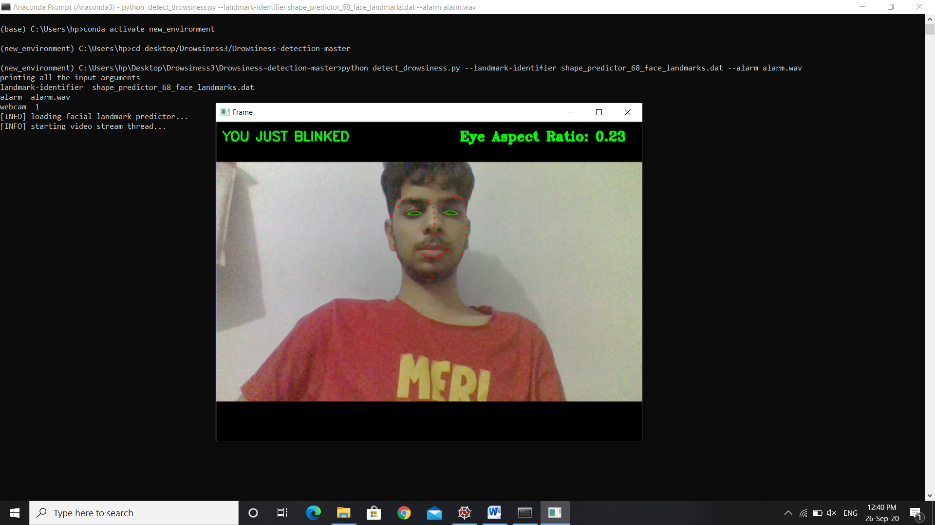

FIGURE 2 – EYE BLINKING NOTIFICATION

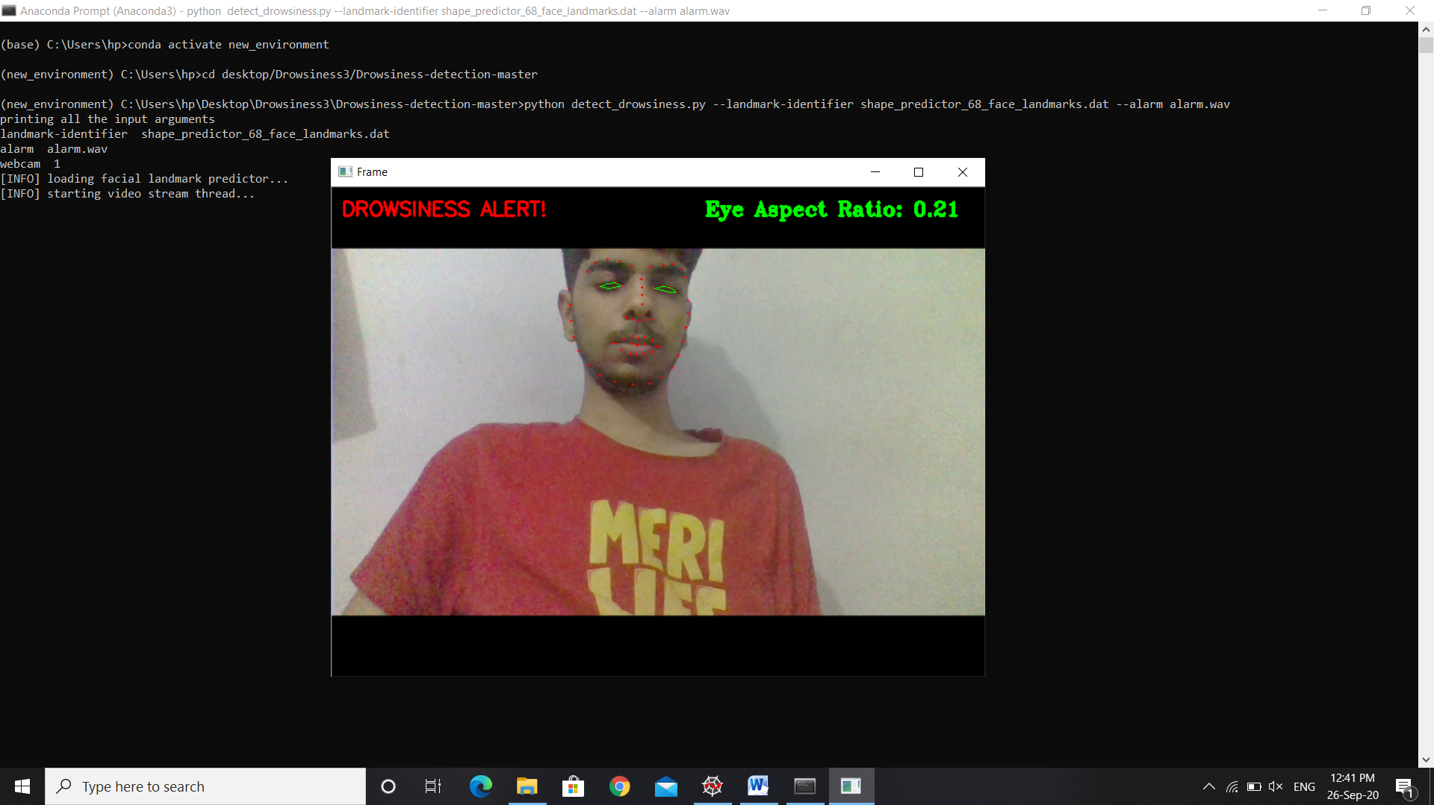

FIGURE 3 – DROWSINESS ALERT THROUGH ALARM

1. **CONCLUSION**

The driver abnormality monitoring system developed is capable of detecting drowsiness, drunken and reckless behaviours of driver in a short time. The Drowsiness Detection System developed based on eye closure of the driver can differentiate normal eye blink and drowsiness and detect the drowsiness while driving. The proposed system can prevent the accidents due to the sleepiness while driving. The system works well even in case of drivers wearing spectacles and even under low light conditions if the camera delivers better output. Information about the head and eyes position is obtained through various self-developed image processing algorithms. During the monitoring, the system is able to decide if the eyes are opened or closed. When the eyes have been closed for too long, a warning signal is issued. processing judges the driver’s alertness level on the basis of continuous eye closures.

1. **FUTURE SCOPE**

The model can be improved incrementally by using other parameters like blink rate, yawning, state of the car, etc. If all these parameters are used it can improve the accuracy by a lot. We plan to further work on the project by adding a sensor to track the heart rate in order to prevent accidents caused due to sudden heart attacks to drivers. Same model and techniques can be used for various other uses like Netflix and other streaming services can detect when the user is asleep and stop the video accordingly. It can also be used in application that prevents user from sleeping.

1. **BIBLIOGRAPHY**
2. SCHLKOPF-A. BLAKE, S. ROMDHANI, AND P. TORR.
3. USE OF THE HOUGH TRANSFORMATION TO DETECT LINES AND CURVES IN PICTURE; R. DUDA AND P. E. HART.
4. JAIN, “FACE DETECTION IN COLOR IMAGES; R. L. HSU, M. ABDEL- MOTTALEB, AND A. K. JAIN.
5. OPEN/CLOSED EYE FOR DROWSINESS DETECTION; P.R. TABRIZI AND R.A. ZOROOFI.
6. WIKIPEDIA.
7. PYHTON.ORG.